**TABLE OF CONTENTS**

**I. PRE-OJT REQUIREMENTS**………………………………………………………………………………………………………………………………….…….…………1-6

ACCOMPLISHED REQUIREMENTS CHECKLIST……………………………………………………………………………………………….……………………………………….1

PRE-OJT ORIENTATION CERTIFICATE………………………………………………………………………………………………………………………………………….………….2

STUDY LOAD ………………………………………….………………………………………………………………………………………………………………………….……………..….3

MEDICAL CERTIFICATE……………………………………………………………………………………………………………………………..……………………….………………….4

HEALTH INSURANCE………………………………………………………………………………………………………………………………………………………….………………….5

VACCINATION CARD………………………………………………………………………………………………………………………………………………………….………………….6

**II. PRE-OJT ASSESSMENTS ESSAY**………………………………………………………………………………………………………………………………………..…….7

WHO AM I………………………………………………………………………………………………………………………………………………………………………….…………..…….7

**III. ON-THE-JOB-TRAINING REQUIREMENTS**…………………………………………………………….………………………………….……………………….8-16

APPLICATION FORM FOR OJT…………………………………………………………………………………………………………………………………..……………………….….8

RESUME…………………………………………………………………………………………………………………………………………………………………………………………..9-10

PARENTS CONSENT………………………………………………………………………………………………………………………………………………………..……………….….11

APPLICATION LETTER……………………………………………………………………………………………………………………………………………………………………...….12

MOA……………………………………………………………………………………………………………………………………………………………………….…………………….13-15

ENDORSEMENT LETTER………………………………………………………………………………………………………………………………………………………………………16

**IV. ON-THE-JOB TRAINING REPORTS**………………………………………………………………………………………………………………………………….17-40

**V. POST-ON-THE-JOB TRAINING REPORT**…………………………………………………………………………………………………………………………41-48

DTR/ATTENDANCE…………………………………………………………………………………………………………………………………………………………………………41-42

CERTIFICATE OF COMPLETION…………………………………………………………………………………………………………………….………………………………………43

OJT JOURNEY………………………………………………………………………………………………………………………………………………………………………………………44

PERFORMANCE EVALUATION…………………………………………………………………………………………………………………………………………………………45-47

OJT PRESENTATION……………………………………………………………………………………………………………………………………………………………………………..48

**ACCOMPLISHED REQUIREMENTS CHECKLIST**

* **Requirements Checklist**

Name : Chiantine P. Manigos_________________________________________________________________

Course : Bachelor of Science in Computer Science__________________________________________________

Year Level : Fourth Year__________________________________________________________________________

Email Address : [cmanigos@gmail.com______](mailto:cmanigos@gmail.com______)___________________________________________________________

Cellphone # : **09163609855___________________________________________________________**

|  |  |  |
| --- | --- | --- |
| **Documents** | **Date Submitted** | **Remarks** |
| OJT Application Form |  |  |
| Medical Certificate |  |  |
| Parent’s Consent and Waiver |  |  |
| Study Load |  |  |
| Pre – OJT Orientation Certificate of Attendance |  |  |
| Application Letter |  |  |
| Resume |  |  |
| Endorsement Letter |  |  |
| Memorandum of Agreement |  |  |

* **Induction Checklist**

Name : Chiantine P. Manigos_________________________________________________________________

Course : Bachelor of Science in Computer Science __________________________________________________

HTE : ___________________________________________________________________________________

Immediate Supervisor : ___________________________________________________________________________________

|  |  |  |  |
| --- | --- | --- | --- |
| **TASK** | **EXPLAIN** | **DATE** | **INITIAL** |
| Company Information |  |  |  |
| Company Policies |  |  |  |
| Hours of Work |  |  |  |
| Tour of the Workplace |  |  |  |
| Introductions |  |  |  |
| Health Safety Standards |  |  |  |
| Emergency Procedures |  |  |  |
| Standards of Performance and Documents |  |  |  |
| Work and Training Plan |  |  |  |
| Customer Relations |  |  |  |
| Record of Learning and Documents |  |  |  |

Date of Induction : ___________________________________________________________________________________________

Signature of OJT : ___________________________________________________________________________________________

Training Supervisor Signature: ___________________________________________________________________________________

**PRE-OJT ORIENTATION CERTIFICATE**

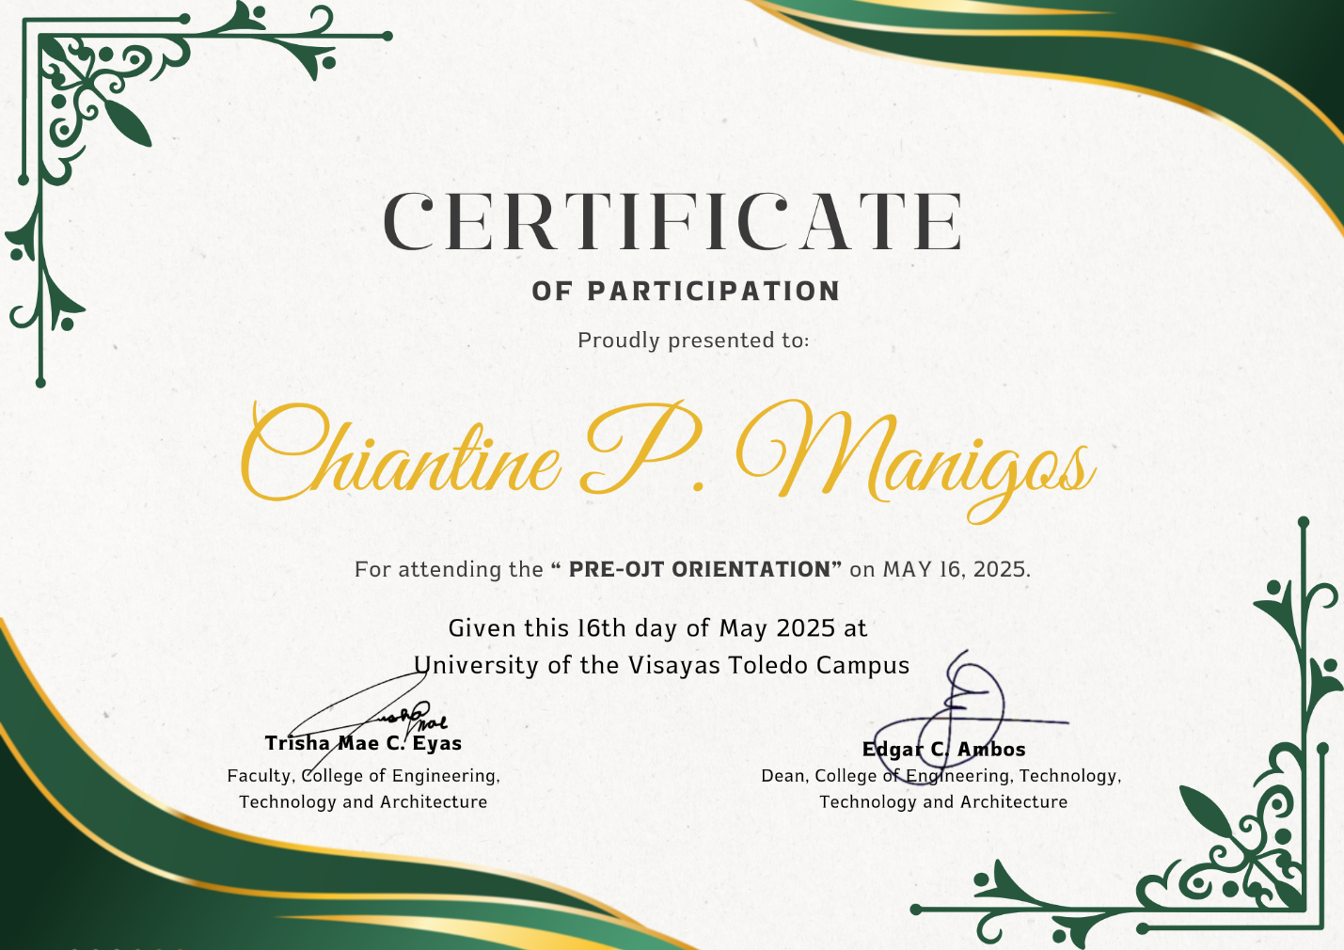

**STUDY LOAD**

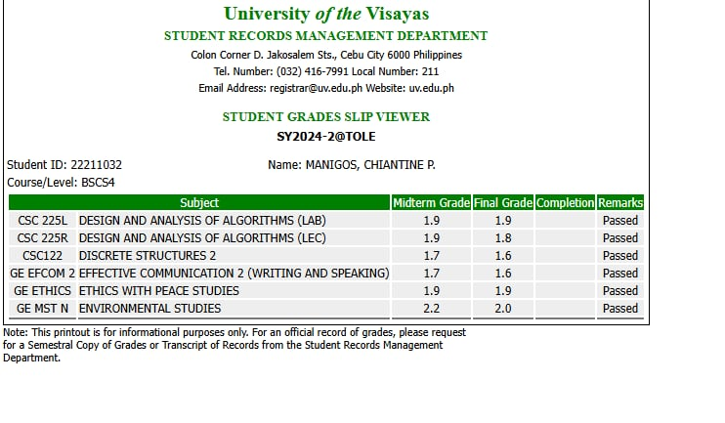

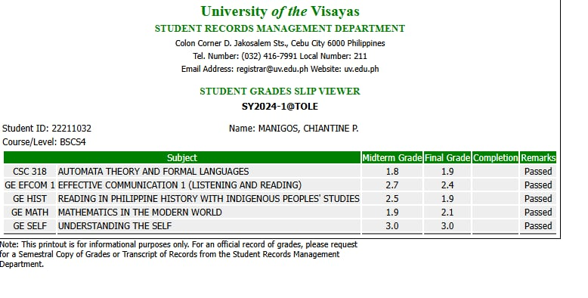

**MEDICAL CERTIFICATE**

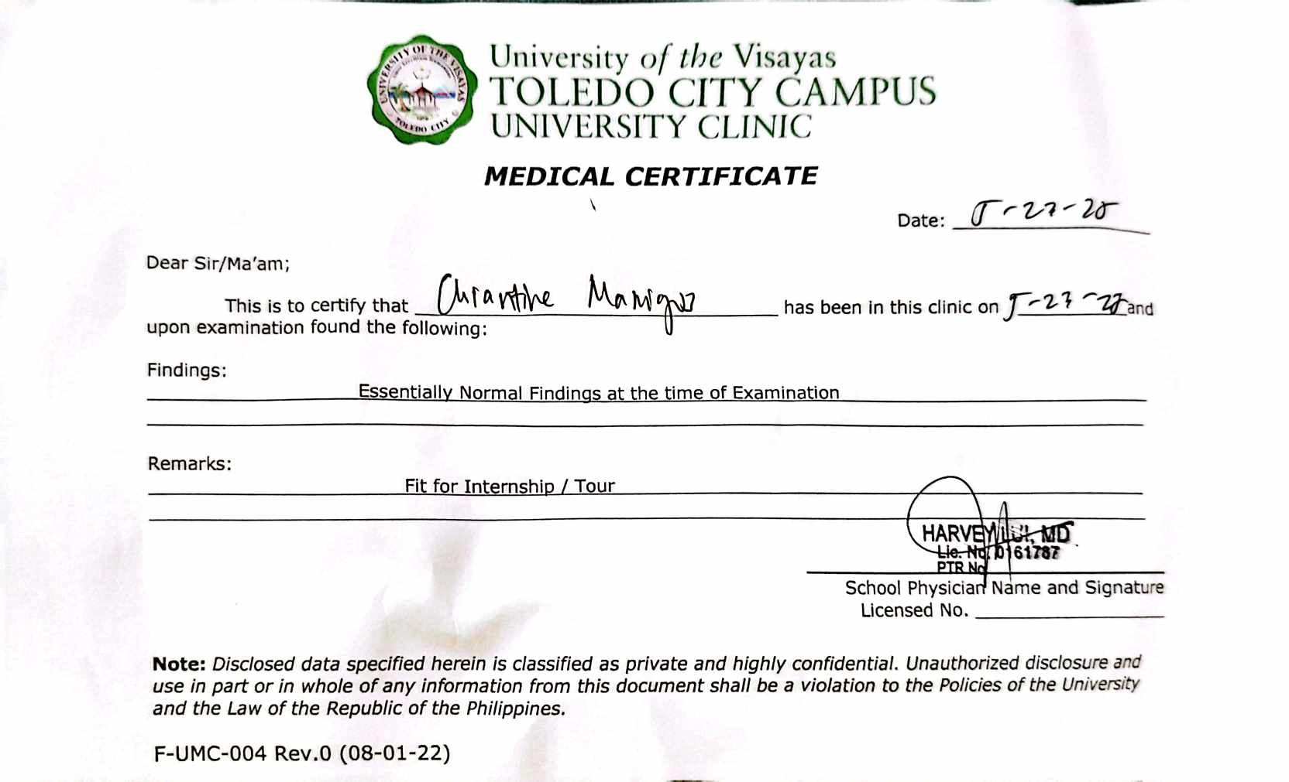

**HEALTH INSURANCE**

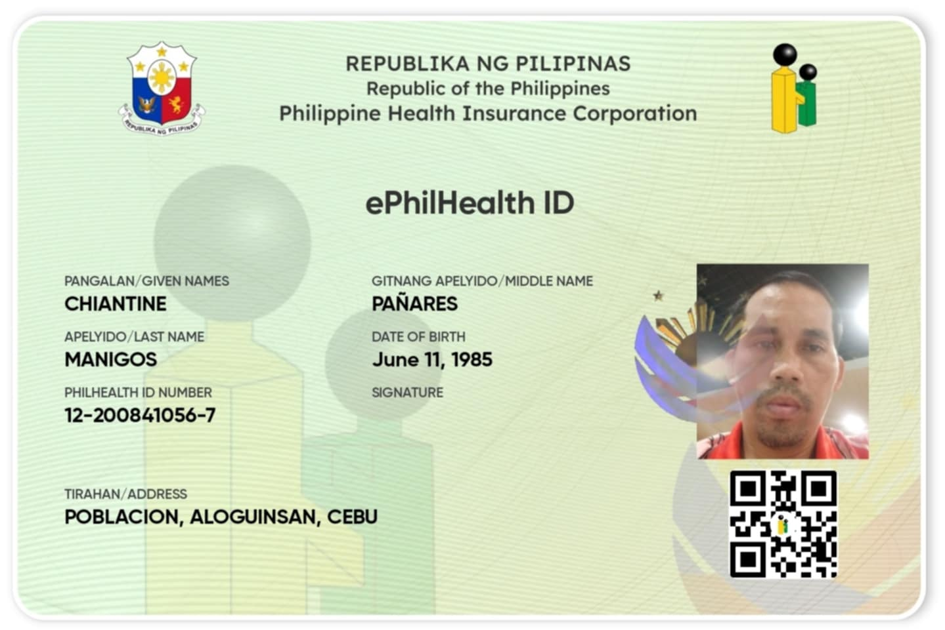

**VACCINATION CARD**

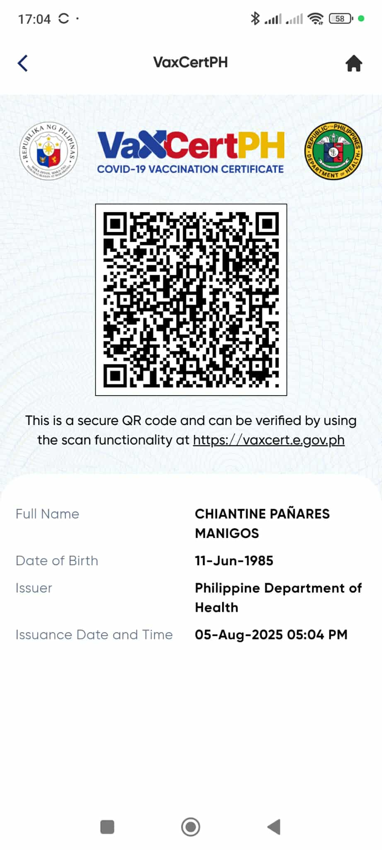

**NAME:** Chiantine P. Manigos **DATE:** May 30, 2025

**COURSE/ YEAR:** BSCS 4

**WHO AM I**

Directions: Write a minimum of 500-word Reflective Essay “WHO AM I”. Write your reflective essay on the space provided below. Kindly refer to the Reflective Essay Rubric in the succeeding page for you to know and understand what the instructor’s expectation for the reflective essay is and how you will be graded.

**WHO AM I**

As I see myself in the mirror, I ask to myself who really am I, and what kind of person I want to be? We are all being asked this kind of questions, as we met a lot of people in our lives and we can actually give them a little bit of details about ourselves. But have we ever tried to asked ourselves, if what kind of person are we, or who truly we are as a human being. A lot of persons don’t know deeply about there-self, and I am one of them.

Who am I, as a person, student, friend, a part of the family, and also the youngest son with a broken family.

I came from a broken family; I grow up in my grandmother’s side together with my older sister. I grow up without my father. It is just my mother who take risk to work far away from our home so that she can provide our family. Growing up as an youngest son without my mother and father by my side is not healthy for me. I always longed for a love, guidance, care, and everything that a parents can give their child. But I cannot blame both of them for not giving us the family that every child must have.

So, if someone ask me who am I; I will always answer them that I am just a simple man who grew up with a lot of insecurities and a lack of everything in my life. I grew seeking for validation in another people. I grew craving for my family’s attention. As I grew up, as I get older there is a lot of questions that I cannot understand and I cannot even give an answer on one of them. Every day, I always make time to understand myself deeply. As I get older, I tried to know me more deeply, because I know within myself that I did not know my self deeply as what I want.

Growing up in today’s generation is crucial because of the people around us. That is why I always check myself for me to fully understand who truly I am. But as of now, I promised myself to let things flow in my life, to not be stressed and pressured of what’s coming in my life. I want to treasure every little achievement that I have right now.

To fully introduce myself of who am I as a person; I am a loving, caring, understanding, and hopeful son, student, and a friend, despite everything that is happening in my life. Because I truly believed that everything happens for a reason. Despite how cruel the world towards us, we must continue to move forward in order for us be better and to reached our destinations in this life that we have.

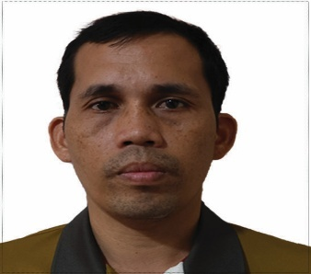

**APPLICATION FOR OJT**

Program : Bachelor of Science in Computer Science _________________

Student Name : Chiantine P. Manigos_________________________________

Student ID # : 22211032___________________________________________

Address : Bojo, Aloguinsan, Cebu_______________________________________________________

Mobile No : 09163609855________________________________________________________________

Email Address : [cmanigos@gmail.com](mailto:cmanigos@gmail.com)________________________________________________________

Number of Hours : 500_______________________________________________________________________

Name of the Company : Municipality of Aloguinsan____________________________________________________

Company Address : Purok 2, Poblacion, Aloguinsan, Cebu____________________________________

Telephone Number : __________________________________________________________________________

Designated person to sign

the MOA : __________________________________________________________________________

Position of the designated

person : __________________________________________________________________________

Mobile Number/ Email Add: __________________________________________________________________________

Name of Immediate : __________________________________________________________________________

Supervisor : __________________________________________________________________________

Mobile Number : __________________________________________________________________________

Address : __________________________________________________________________________

**Pre- Practicum Requirements** **Company Requirements**

Medical Certificate ***(for new company)***

Waiver issued and sign by Practicum Program/ Training Plan

Parents/guardian/spouse

Company Profile

Parent’s Consent SEC/DTI

Photocopy of the recent study BIR Certificate of Registration

load(photocopy)

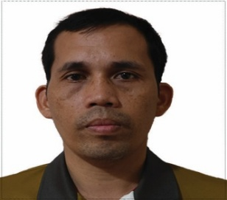**RESUME**

**CHIANTINE P. MANIGOS**

**BOJO, ALOGUINSAN, CEBU**

**0916 360 9855**

**cmanigos@gmail.com**

**CAREER OBJECTIVES:**

Seeking a challenging opportunity where I will able to utilize my strong organization skills, educational background, and ability to work well with people, which will allow me to grow personally and professionally.

**SUMMARY QUALIFICATION**

* Willing to be trained
* Good at communicating other people
* Can adopt new environment
* Dedicated and hardworking individual or part of a team
* The ability to work under pressure and multi-tasking

**EDUCATIONAL BACKGROUND**

|  |  |
| --- | --- |
| Tertiary | : University of the Visayas – Toledo Campus |
|  | Bachelor of Science in Computer Science |
|  | 2021 - 2025 |
| Secondary | : Aloguinsan National High School  2008-2009 |
| Elementary | : Aloguinsan Central Elementary School |
|  | 2005-2006 |

**CHARACTER REFERENCES**

**ENGR. RICHARD T. SAING,** *Ph. D, P. Eng.*

Dean

College of Engineering, Technology and Architecture

School of Graduate Engineering

+63 927 464 2829

Arvin D. Gutang

Faculty

College of Engineering, Technology, and Architecture

+63 977 326 7665

**PARENTS CONSENT**

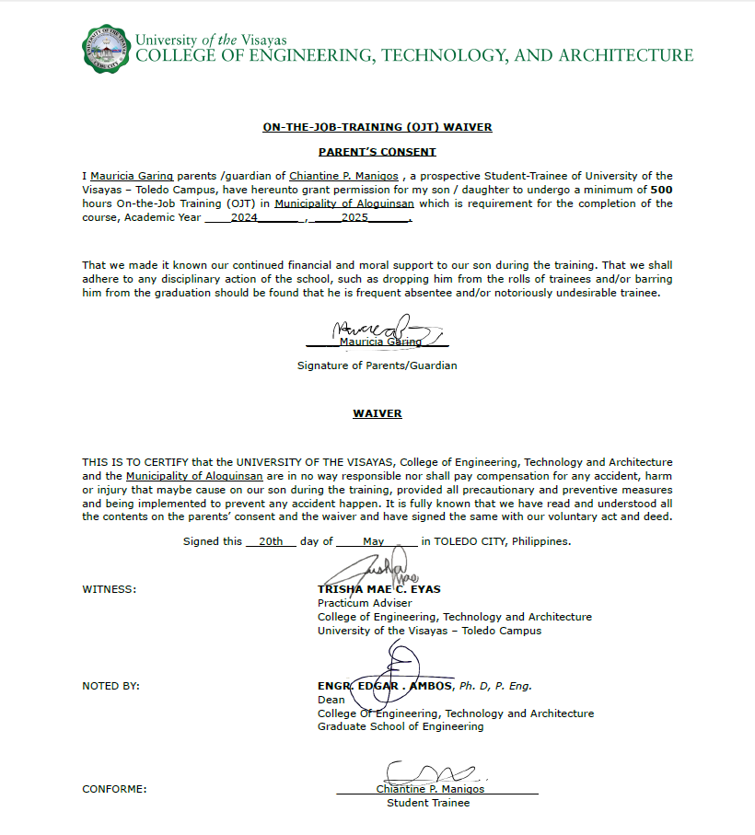

**APPLICATION LETTER**

Poblacion Aloguinsan,

Cebu 6040

May 30, 2025

Mrs. Doreen Triplitt

Human Resource Management Officer III

Municipality of Aloguinsan

Good day Ma’am:

A woman with high regard for your institution, and with the earnest desire to serve in the capacity in which the following qualification was most adopted, is humbly applying for a position as an **On-the-Job Training.**

I am **Chiantine P. Manigos**, 40 years of age, Married, Filipino, and a resident of Bojo, Aloguinsan, Cebu. I am currently a fourth-year college student studying in University of the Visayas Toledo Campus with the degree of Bachelor of Science in Computer Science through my perseverance, dedication and hard work of studying to achieve my goal with the help of our Almighty God. I also joined different organization, in and out of the school and in our community that helped me develop my leadership and self-confidence.

Though the span of my studying and experienced attained and I hope that my skills and ability as well as my knowledge would indeed be a match for the position that requires in every applicant as an On-the-Job Trainee.

I am optimistic that all my qualification as applicant would meet your standards in getting as On the Job Trainee (OJT) as well as I am much willing to gain more knowledge and skills in my days of training.

Thank you so much and I’ll wait for your favorable response.

Respectfully yours,

Chiantine P. Manigos

**MOA**

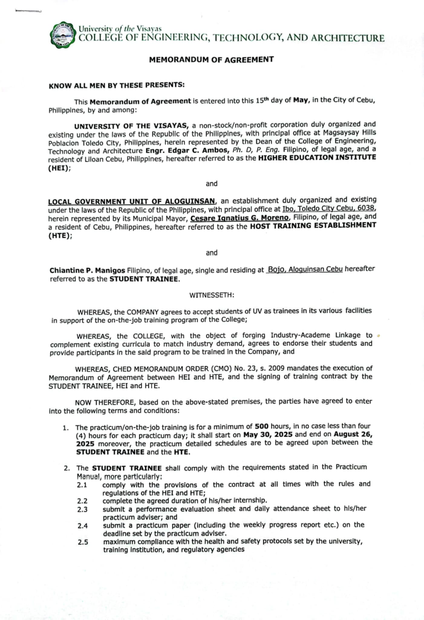

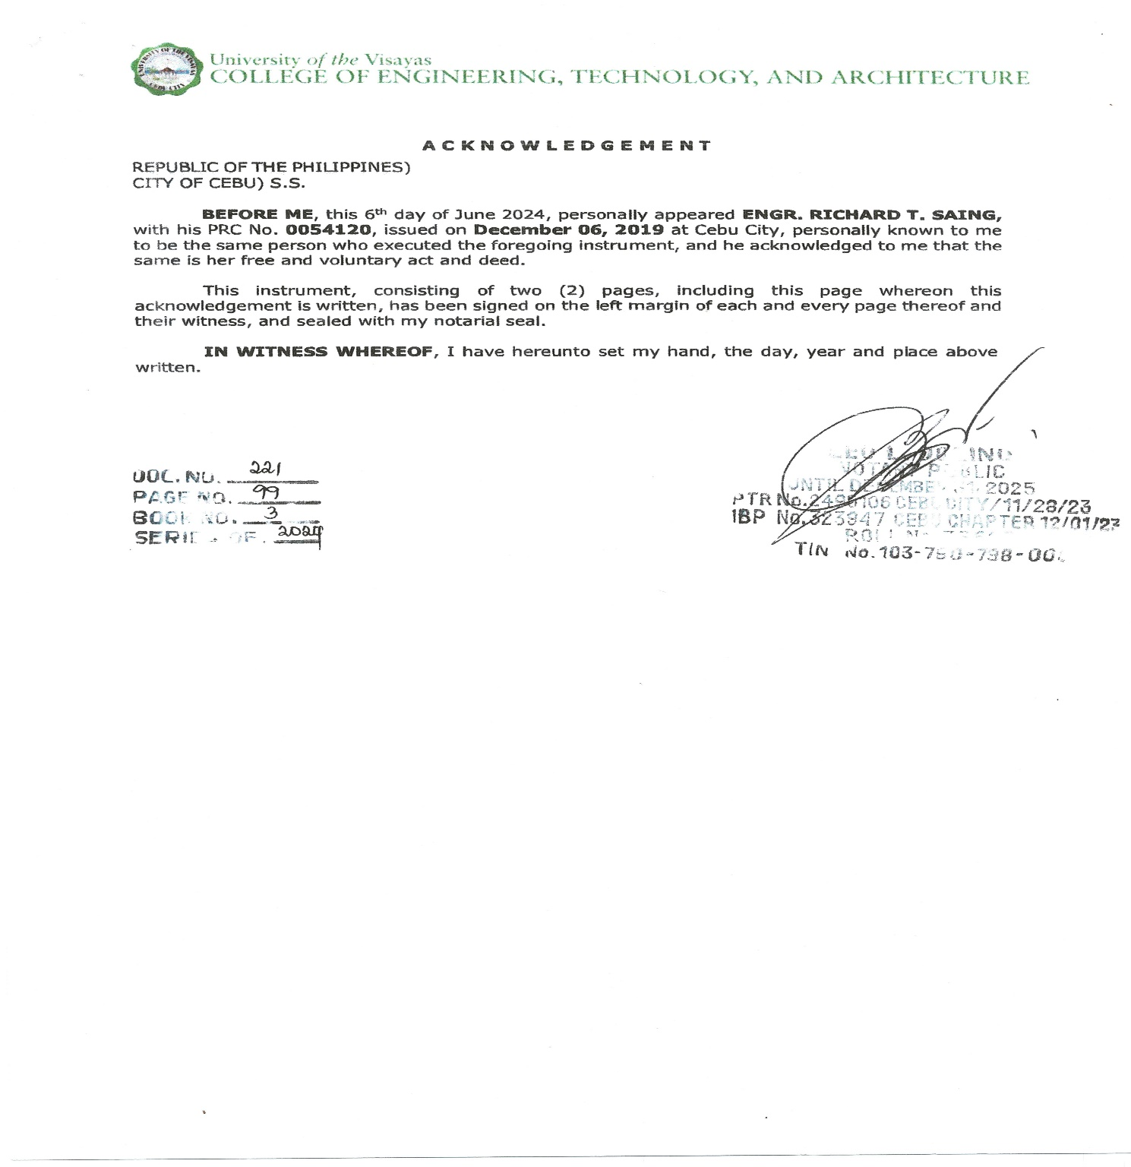

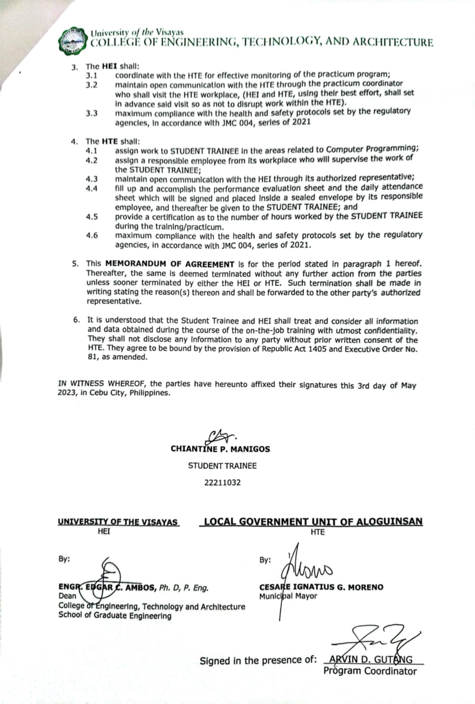

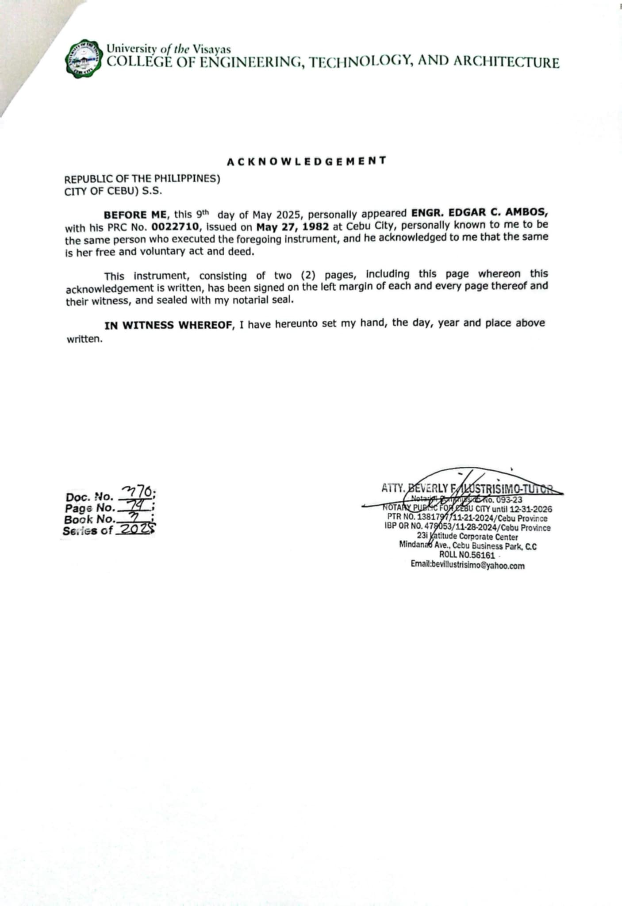

**ENDORSEMENT LETTER**

**ON-THE-JOB-TRAINING (OJT) ENDORSEMENT LETTER**

May 30, 2025

Doreen Triplitt

Human Resource Management Officer III

Municipality of Aloguinsan

**Subject: Endorsement for On-the-Job Training (Apprenticeship)**

Dear Ma’am Triplitt:

Pursuant to the directive of the Commission on Higher Education (CHED), we are setting up the mandated “On-the-Job Training (Apprenticeship) Program” as a co-curricular requirement for the completion of the degree: **Bachelor of Science in Computer Science**.

We are confident that your establishment has the adequate resources and facilities that will provide the students the opportunity to gain useful insights and worthwhile experiences in the actual work environment through a relevant “On-the-Job Training Program”.

In accordance to the Cooperative Training Program prescribed by the Department of Labor and Employment (DOLE), an apprentice may be required to work at a minimum of four (8) hours per day from Monday to Friday.

In view of the foregoing, we have the pleasure and privilege of recommending our student, **Mr. Chiantine P. Manigos** to have his practicum in your good office at least a minimum of **500** – hours this **SUMMER** of AY **2024-2025**. The services rendered by the apprentice may not be compensated in any form of wage, allowance, tip, commission or stipend.

We are endorsing his resume for your ready reference and file.

Trusting that this matter will merit your kind consideration and cooperation. Whatever assistance you may give to our student will be highly appreciated.

Thank you.

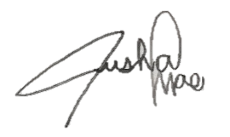Very truly yours,

**TRISHA MAE C. EYAS**

Practicum Adviser

College of Engineering, Technology and Architecture

University of the Visayas – Toledo Campus

Noted by:

Digitally Signed by:

Richard T. Saing

June 5, 2024 @ 7:30 AM

**ENGR. RICHARD T. SAING***, Ph.D., P.Eng.*

Dean

College of Engineering, Technology and Architecture

School of Graduate Engineering



|  |  |
| --- | --- |
| **ACTION TO THE ENDORSEMENT**  (to be filled up by the Host-Training Establishment representative) | |
| [ /] Accepted | Starts on : May 30, 2025 |
| [ ] Not Accepted | Reason/s: |

Signature Over Printed Name

*F-CETA-002 Rev.0 (08-01-2022*)

**ON THE JOB TRAINING REPORTS**

**On-The Job Training Daily Report**

**Week 1**

**Name of Trainee: CHIANTINE P. MANIGOS**

**Course : BACHELOR OF SCIENCE IN COMPUTER SCIENCE**

**Company : LOCAL GOVERNMENT UNIT OF ALOGUINSAN**

**Department : DISASTER RISK REDUCTION & MANAGEMENT OFFICE**

*The trainee should give a brief but clear report on training performed its purpose and how it is accomplished. Indicate also, machine, equipment, tools and materials used, if any.*

|  |  |
| --- | --- |
| Date : **MAY 30, 2025**  Time In : **7:30 A.M**  Time Out : **5:00 P.M**  Hours Spent : **8 HOURS**    Certified Correct:  Mrs. Doreen Triplitt  **Human Resource Officer**  Supervisor/ Trainer | **Task:**  1st day of OJT, my task is to encode all of the PCR Pre-hospital Care Report patients.    **Equipment/Machine used:**  DRRM Office Desktop Computer. |
| Date : **JUNE 1, 2025**  Time In : **7:30 A.M**  Time Out : **5:00 P.M**  Hours Spent : **8 HOURS**    Certified Correct :  Ms. Ella Mae P. Fabroa  **HR and Admin Officer**  Supervisor/ Trainer | **Task:**  2nd working day as OJT in CEBECO III, my task is keeping on with my work in encoding all of the consumer’s personal contact number.    **Equipment/Machine used:**  CEBECO III personal computer. |

20

|  |  |
| --- | --- |
| Date : **JUNE 19, 2024**  Time In : **7:30 A.M**  Time Out : **5:00 P.M**  Hours Spent : **8 HOURS**    Certified Correct :  Ms. Ella Mae P. Fabroa  **HR and Admin Officer**  Supervisor/ Trainer | **Task:**  Day 3 of OJT, still working on encoding the consumer’s number.  Hand over some important document to another department.  Preparing and organizing letters for possible AGMA guests.    **Equipment/Machine used:**  CEBECO III personal computer. |
| Date : **JUNE 20, 2024**  Time In : **7:30 A.M**  Time Out : **5:00 P.M**  Hours Spent : **8 HOURS**  Certified Correct :  Ms. Ella Mae P. Fabroa  **HR and Admin Officer**  Supervisor/ Trainer | **Task:**  4th day of OJT, noting all the incoming emails of CEBECO III.  Cutting plastics for banners or bunting. Handing over important documents on another department.    **Equipment/Machine used:**  Plastics for banner  Scissors  Plastic straw rope  Stapler  211 |
| Date : **JUNE 21, 2024**  Time In : **7:30 A.M**  Time Out : **5:00 P.M**  Hours Spent : **8 HOURS**  Certified Correct :  Ms. Ella Mae P. Fabroa  **HR and Admin Officer**  Supervisor/ Trainer | **Task:**  Making lei garlands.  Inputting consumer’s cellphone number.    **Equipment/Machine used**  CEBECO III personal computer  Scissor  Stick Glue  Glue gun  Garland materials |

**On-The Job Training Daily Report**

**Week 2**

**Name of Trainee: SHERYL JOY P. PILOTO**

**Course : BACHELOR OF SCIENCE IN COMPUTER SCIENCE**

**Company : CEBU III ELECTRIC COOPERATIVE, INC.**

**Department : ISD / ADMIN OFFICE***The trainee should give a brief but clear report on training performed its purpose and how it is accomplished. Indicate also, machine, equipment, tools and materials used, if any.*

|  |  |
| --- | --- |
| Date : **JUNE 24, 2024**  Time In : **7:30 A.M**  Time Out : **5:00 P.M**  Hours Spent : **8 HOURS**    Certified Correct :  Ms. Ella Mae P. Fabroa  **HR and Admin Officer**  Supervisor/ Trainer | **Task:**  Encoding the MCO’s personal contact number.  Writing down numbers in registration form for AGMA.    **Equipment/Machine used:**  CEBECO III personal computer |
| Date : **JUNE 25, 2024**  Time In : **7:30 A.M**  Time Out : **5:00 P.M**  Hours Spent : **8 HOURS**    Certified Correct :  Ms. Ella Mae P. Fabroa  **HR and Admin Officer**  Supervisor/ Trainer  Date : **JUNE 26, 2024**  Time In : **7:30 A.M**  Time Out : **5:00 P.M**  Hours Spent : **8 HOURS**    Certified Correct :  Ms. Ella Mae P. Fabroa  **HR and Admin Officer**  Supervisor/ Trainer | **Task:**  Ongoing with my work in writing down number on registration form for AGMA. Arranging all the registration form for AGMA.    **Equipment/Machine used:**  **Task:**  Encoding MCO’s personal contact number. Arranging all the travel forms of CEBECO III together with the immersions      **Equipment/Machine used:**  CEBECO III personal computer |

|  |  |
| --- | --- |
| Date : **JUNE 27, 2024**  Time In : **7:30 A.M**  Time Out : **5:00 P.M**  Hours Spent : **8 HOURS**    Certified Correct :  Ms. Ella Mae P. Fabroa  **HR and Admin Officer**  Supervisor/ Trainer | **Task:**  Checking all raffle drum in the auditorium.  Headed to radio room to deliver documents. Fetch the tarpaulin in IT department together with the immersions.    **Equipment/Machine used:** |

**On-The Job Training Daily Report**

**Week 3**

**Name of Trainee: SHERYL JOY P. PILOTO**

**Course : BACHELOR OF SCIENCE IN COMPUTER SCIENCE**

**Company : CEBU III ELECTRIC COOPERATIVE, INC.**

**Department : ISD / ADMIN OFFICE**

*The trainee should give a brief but clear report on training performed its purpose and how it is accomplished. Indicate also, machine, equipment, tools and materials used, if any.*

27

|  |  |
| --- | --- |
| Date : **JULY 05, 2024**  Time In : **7:30 A.M**  Time Out : **5:00 P.M**  Hours Spent : **8 HOURS**    Certified Correct :  Ms. Ella Mae P. Fabroa  **HR and Admin Officer**  Supervisor/ Trainer | **Task:**  4th day of continued task to track the  membership number of all AGMA attendee    **Equipment/Machine used:**  CEBECO III personal computer. |
| Date : **JULY 08, 2024**  Time In : **7:30 A.M**  Time Out : **5:00 P.M**  Hours Spent : **8 HOURS**  Certified Correct :  Ms. Ella Mae P. Fabroa  **HR and Admin Officer**  Supervisor/ Trainer | **Task:**  Arranging all employees' time records. Relaying important documents to another department.  Securing the registration form from the MCO office.    **Equipment/Machine used:**  CEBECO III personal computer. |

**On-The Job Training Daily Report**

**Week 4**

**Name of Trainee: SHERYL JOY P. PILOTO**

**Course : BACHELOR OF SCIENCE IN COMPUTER SCIENCE**

**Company : CEBU III ELECTRIC COOPERATIVE, INC.**

**Department : ISD / ADMIN OFFICE** *The trainee should give a brief but clear report on training performed its purpose and how it is accomplished. Indicate also, machine, equipment, tools and materials used, if any.*

|  |  |
| --- | --- |
| Date : **JULY 09, 2024**  Time In : **7:30 A.M**  Time Out : **5:00 P.M**  Hours Spent : **8 HOURS**  Certified Correct :  Ms. Ella Mae P. Fabroa  **HR and Admin Officer**  Supervisor/ Trainer | **Task:**  Sorting and duplicating all employee identification cards.  Organizing all employees' daily time record    **Equipment/Machine used:**  CEBECO III personal computer. |
| Date : **JULY 10, 2024**  Time In : **7:30 A.M**  Time Out : **5:00 P.M**  Hours Spent : **8 HOURS**    Certified Correct :  Ms. Ella Mae P. Fabroa  **HR and Admin Officer**  Supervisor/ Trainer  Date : **JULY 11, 2024**  Time In : **7:30 A.M**  Time Out : **5:00 P.M**  Hours Spent : **8 HOURS**    Certified Correct :  Ms. Ella Mae P. Fabroa  **HR and Admin Officer**  Supervisor/ Trainer | **Task:**  Keeping track of all incoming e-mails for CEBECO III.    **Equipment/Machine used:**  CEBECO III personal computer  **Task:**  Checking all of the incoming emails of CEBECO III.  Handed out some important documents to  another department Decorating the board room.    **Equipment/Machine used:**  CEBECO III personal computer  Balloons, Balloon pump, |

|  |  |
| --- | --- |
| Date : **JULY 12, 2024**  Time In : **7:30 A.M**  Time Out : **5:00 P.M**  Hours Spent : **8 HOURS**    Certified Correct :  Ms. Ella Mae P. Fabroa  **HR and Admin Officer**  Supervisor/ Trainer | **Task:**  Checking all incoming and outgoing emails of CEBECO III.  Copy and paste all of the important details of the emails.    **Equipment/Machine used:**  CEBECO III personal computer |
| Date : **JULY 15, 2024**  Time In : **7:30 A.M**  Time Out : **5:00 P.M**  Hours Spent : **8 HOURS**    Certified Correct :  Ms. Ella Mae P. Fabroa  **HR and Admin Officer**  Supervisor/ Trainer | **Task:**  Tracking and collecting the important details of the outgoing emails of CEBECO III Handing over important documents to another department.    **Equipment/Machine used:**  CEBECO III personal laptop |

**On-The Job Training Daily Report**

**Week 5**

**Name of Trainee: SHERYL JOY P. PILOTO**

**Course : BACHELOR OF SCIENCE IN COMPUTER SCIENCE**

**Company : CEBU III ELECTRIC COOPERATIVE, INC**

**Department : ISD / ADMIN OFFICE**

*The trainee should give a brief but clear report on training performed its purpose and how it is accomplished. Indicate also, machine, equipment, tools and materials used, if any.*

|  |  |
| --- | --- |
| Date : **JULY 16, 2024**  Time In : **7:30 A.M**  Time Out : **5:00 P.M**  Hours Spent : **8 HOURS**    Certified Correct :  Ms. Ella Mae P. Fabroa  **HR and Admin Officer**  Supervisor/ Trainer | **Task:**  Reviewing all outgoing emails from CEBECO  III.  Gathering key information from the emails. Traveling to another department to fetch some documents.    **Equipment/Machine used:**  CEBECO III personal computer |
| Date : **JULY 17, 2024**  Time In : **7:30 A.M**  Time Out : **5:00 P.M**  Hours Spent : **8 HOURS**    Certified Correct :  Ms. Ella Mae P. Fabroa  **HR and Admin Officer**  Supervisor/ Trainer | **Task:**  Handed important documents in radio room. Returning the photo cutter to the IT department.  Cutting waste paper into smaller pieces.    **Equipment/Machine used:**  Waste Papers  Scissor |

|  |  |
| --- | --- |
| Date : **JULY 18, 2024**  Time In : **7:30 A.M**  Time Out : **5:00 P.M**  Hours Spent : **8 HOURS**  Certified Correct :  Ms. Ella Mae P. Fabroa  **HR and Admin Officer**  Supervisor/ Trainer | **Task:**  Creating markings in MCO’s logbook Name, date, address, contact number and signature  Transferred crucial documents to a different department.    **Equipment/Machine used:**  Logbook, Ballpen, Ruler |
| Date : **JULY 19, 2024**  Time In : **7:30 A.M**  Time Out : **5:00 P.M**  Hours Spent : **8 HOURS**    Certified Correct :  Ms. Ella Mae P. Fabroa  **HR and Admin Officer**  Supervisor/ Trainer | **Task:**  Entering details into Ms. Nafe’s logbook. Hand over the crucial document to the CWD office.  Go to another department to retrieve an important document from the ISD office.    **Equipment/Machine used:**  Logbook, Ballpen, Ruler |
| Date : **JULY 22, 2024**  Time In : **7:30 A.M**  Time Out : **5:00 P.M**  Hours Spent : **8 HOURS**    Certified Correct :  Ms. Ella Mae P. Fabroa  **HR and Admin Officer**  Supervisor/ Trainer | **Task:**  Monitoring all emails sent and received by CEBECO III.  Convey important documents to the Radio Room and CWD office.    **Equipment/Machine used**  CEBECO III personal computer |

**On-The Job Training Daily Report**

**Week 6**

**Name of Trainee: SHERYL JOY P. PILOTO**

**Course : BACHELOR OF SCIENCE IN COMPUTER SCIENCE**

**Company : CEBU III ELECTRIC COOPERATIVE, INC.**

**Department : ISD / ADMIN OFFICE**

*The trainee should give a brief but clear report on training performed its purpose and how it is accomplished. Indicate also, machine, equipment, tools and materials used, if any*

|  |  |
| --- | --- |
| Date : **JULY 23, 2024**  Time In : **7:30 A.M**  Time Out : **5:00 P.M**  Hours Spent : **8 HOURS**    Certified Correct :  Ms. Ella Mae P. Fabroa  **HR and Admin Officer**  Supervisor/ Trainer | **Task:**  Analyzing all incoming emails for Cebeco III and collecting significant data.    **Equipment/Machine used:**  CEBECO III personal computer |
| Date : **JULY 24, 2024**  Time In : **7:30 A.M**  Time Out : **5:00 P.M**  Hours Spent : **8 HOURS**    Certified Correct :  Ms. Ella Mae P. Fabroa  **HR and Admin Officer**  Supervisor/ Trainer | **Task:**  Reviewing all incoming emails for Cebeco III, organizing them into a single file by month and day, and distributing essential paperwork to the appropriate department    **Equipment/Machine used:**  CEBECO III personal computer |

37

|  |  |
| --- | --- |
| Date : **JULY 25, 2024**  Time In : **7:30 A.M**  Time Out : **5:00 P.M**  Hours Spent : **8 HOURS**    Certified Correct :  Ms. Ella Mae P. Fabroa  **HR and Admin Officer**  Supervisor/ Trainer | **Task:**  Scanning all important records of Cebeco III consumers and distributing pertinent documents to the corresponding department. Also, reviewing incoming emails, sorting them into a single file organized by month and day, and managing the documentation process.    **Equipment/Machine used:**  CEBECO III personal computer |
| Date : **JULY 26, 2024**  Time In : **7:30 A.M**  Time Out : **5:00 P.M**  Hours Spent : **8 HOURS**    Certified Correct :  Ms. Ella Mae P. Fabroa  **HR and Admin Officer**  Supervisor/ Trainer | **Task:**  Reviewing emails and compiling key information. Then, forwarding relevant documents to the designated department.    **Equipment/Machine used:**  CEBECO III personal laptop |
| Date : **JULY 29, 2024**  Time In : **7:30 A.M**  Time Out : **5:00 P.M**  Hours Spent : **8 HOURS**    Certified Correct :  Ms. Ella Mae P. Fabroa  **HR and Admin Officer**  Supervisor/ Trainer | **Task:**  Checking all incoming and outgoing emails, collecting the important details of the email then putting it in one file.    **Equipment/Machine used:**  CEBECO III personal computer |

**DTR/ATTENDANCE**

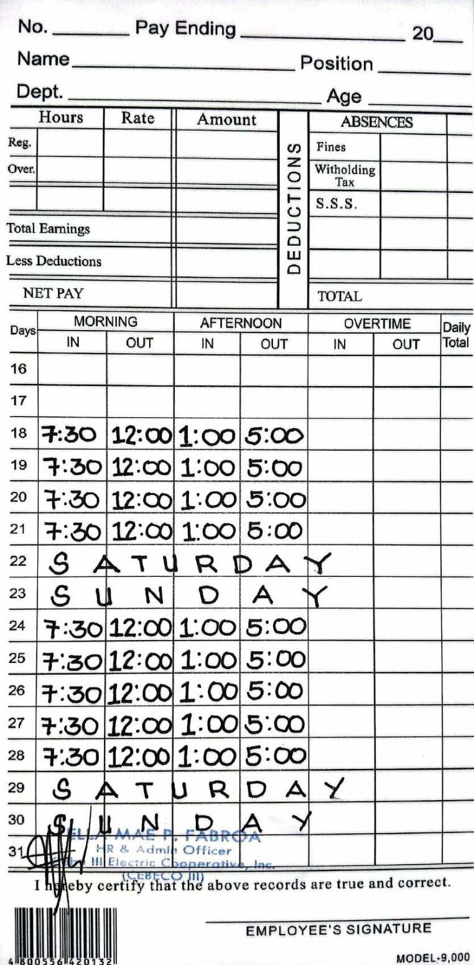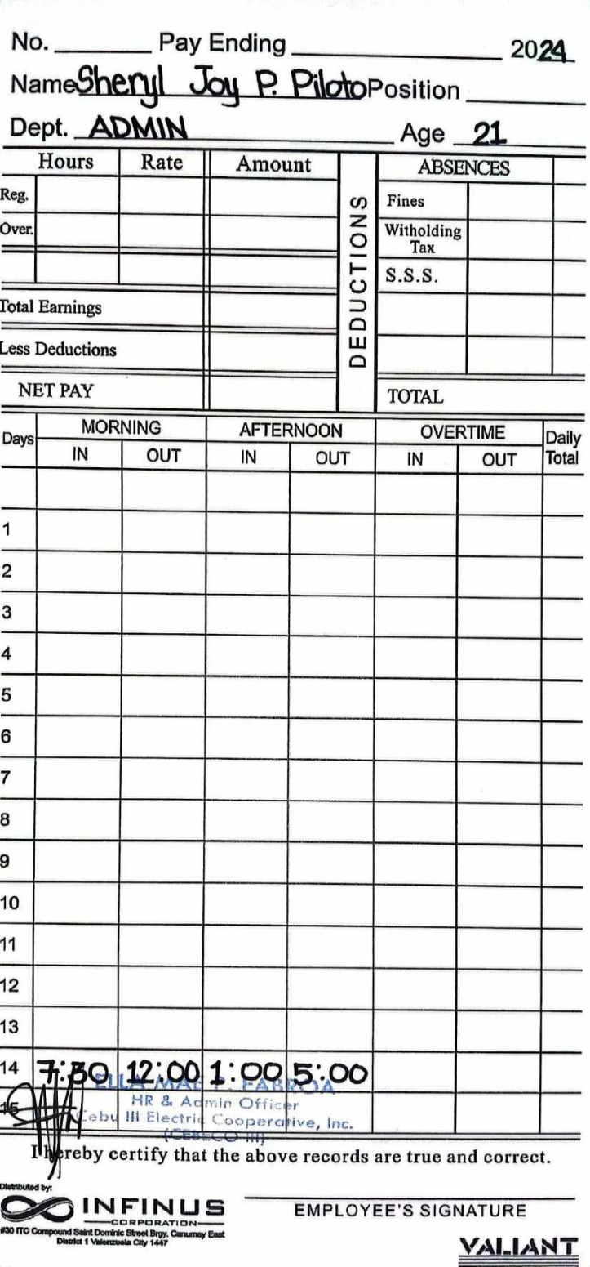**MONTH OF JUNE**

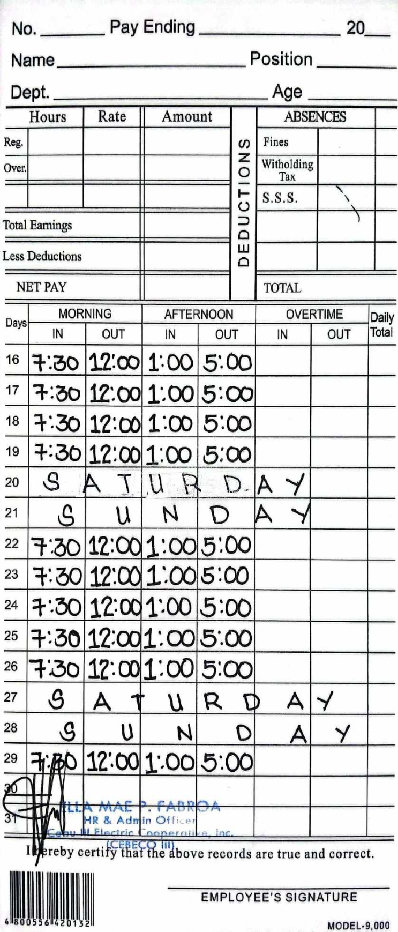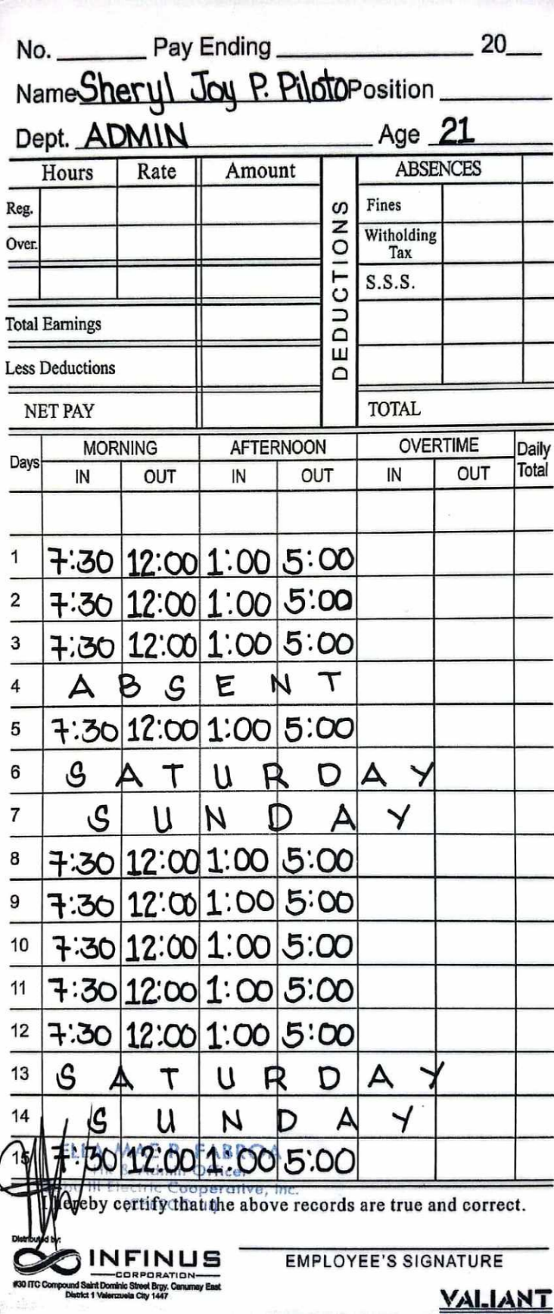**MONTH OF JULY**

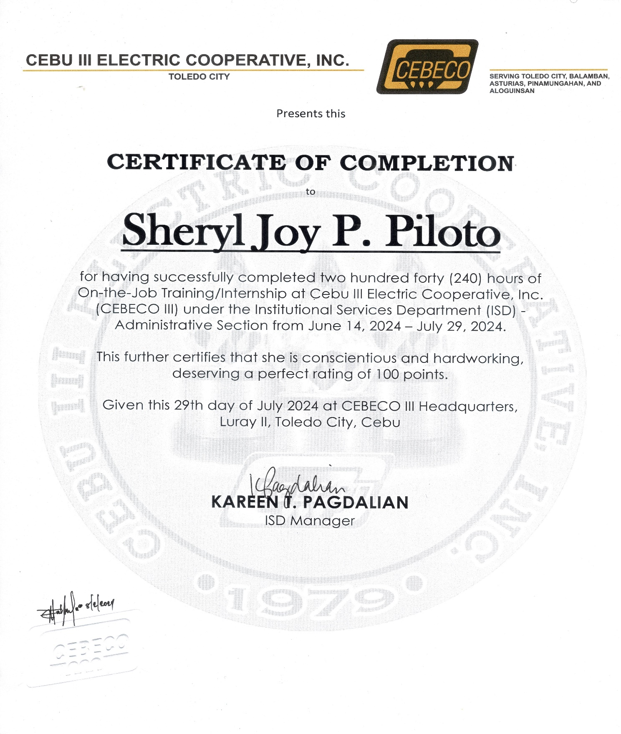**CERTIFICATION OF COMPLETION**

**MY OJT JOURNEY**

**Name of Trainee : SHERYL JOY P. PILOTO**

**Course : BACHELOR OF SCIENCE IN COMPUTER SCIENCE**

**Company : CEBU III ELECTRIC COOPERATIVE, INC.**

**Department : ISD / ADMIN OFFICE**

***Trainee should write an executive summary about his/her journey during his/her***

***OJT period. (Not less than 500 words)***

**REMARKABLE JOURNEY AS AN INTERN**

My journey as an intern in CEBECO III is fun and I learned a lot of lessons during my intern days in CEBECO. During my working days in CEBECO, they let me experience the real world as a worker of a cooperative. At first, I was quite nervous, because it’s my first time to have a on the job training, and CEBECO III is a big cooperative. CEBECO III employee trained me so well about how they work on their designated job. They let me experienced things and taught me a lot of how they work in CEBECO III.

First day of my internship in CEBECO, they already gave me task which is needed to use their personal computer and I was quite hesitant to do it because I am scared that I might broke their computer, but they insist to teach me and they gave their full trust in making the task. I accept the task with full of confidence knowing that it was my first day but they already trusted me to do half of their task. My job in CEBECO III is quite challenging because they put me as their little assistant which is a challenging job for me because half of their works everyday will be forwarded on me. But I am thankful for the opportunity that they gave me because they share a lot of knowledge with me that have a big impact of my life as a student that is craving new learnings every day.

Being part of the admin or ISD office is so challenging for me because of their work. Every day they have a lot of meetings and a lot of paper works. As an intern I need to help each one of them for them to finish their work on time. It is quite challenging because sometimes they gave me task all together, but they will not pressure me to finished it on the time, instead they always encourage me to work well every day.

My journey in CEBECO as an intern in the admin is quite pressure, but everyday they also pushed me to be on my best. CEBECO people taught me a lot of things not just in work but also in life. Even if I am just an intern, the respect that they have for me and they also value me as their intern. As I ended my intern journey in CEBECO III, I pay respect and gave my appreciation to all of them as they gave me warmth welcome in my first until I ended my journey as an intern. I will forever cherish the journey, memories, lessons, and everything that CEBECO III allow me to experience.

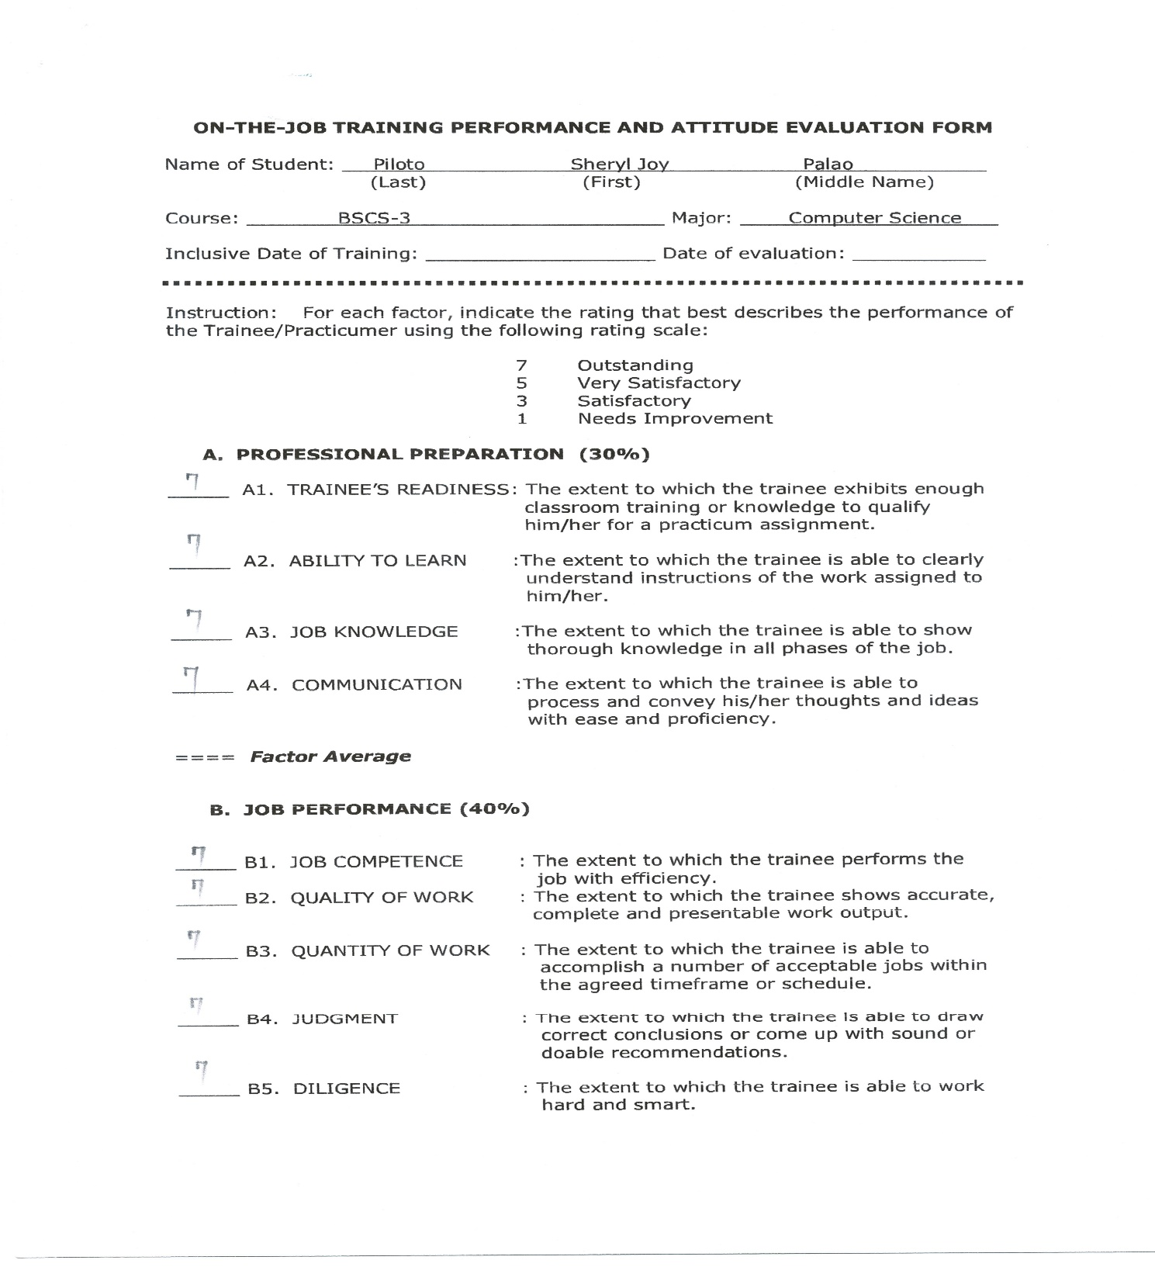**PERFORMANCE EVALUATION**

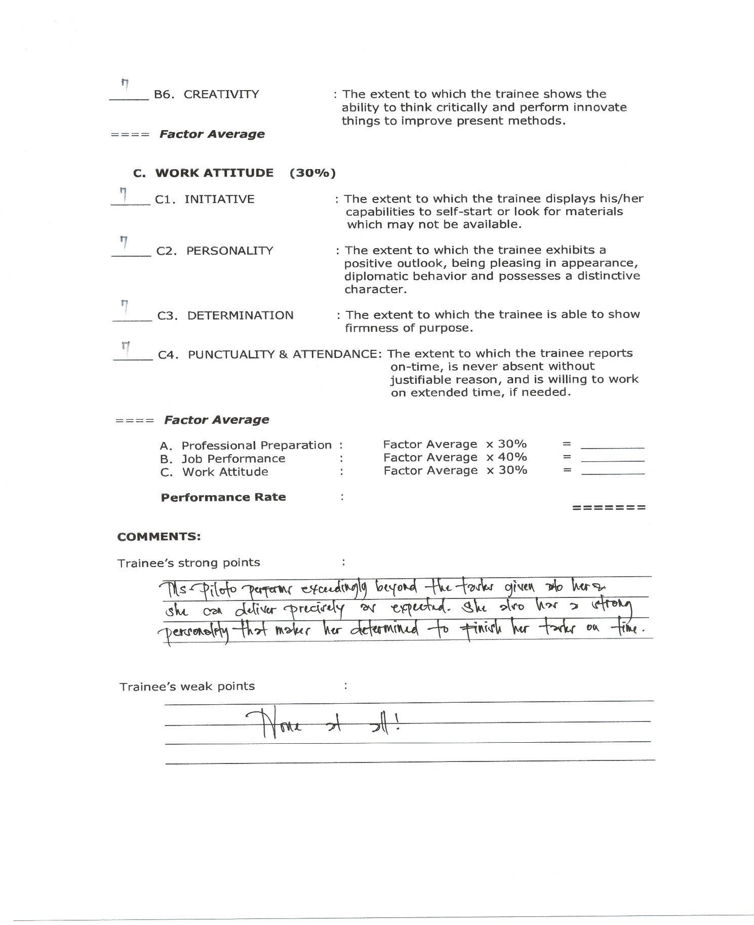

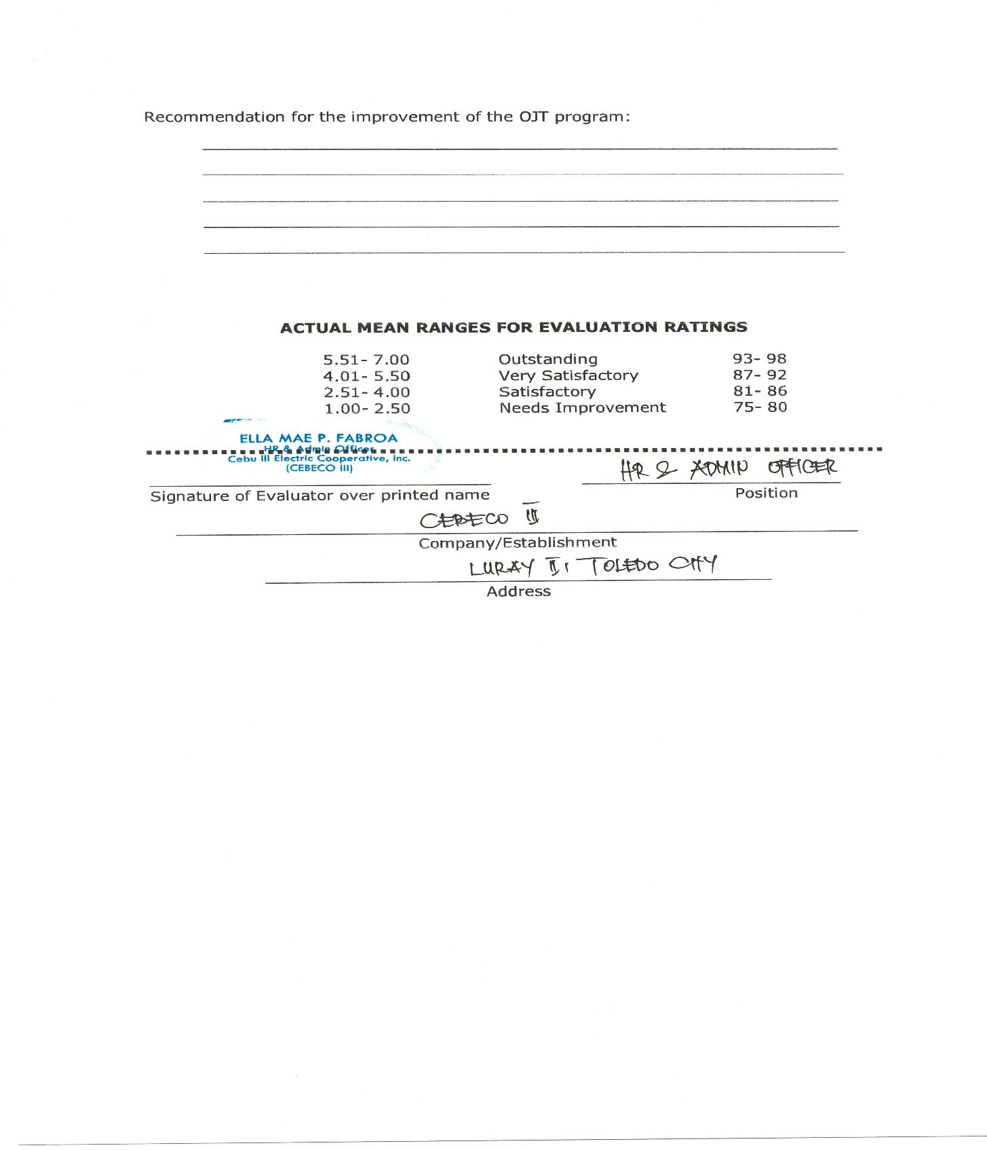

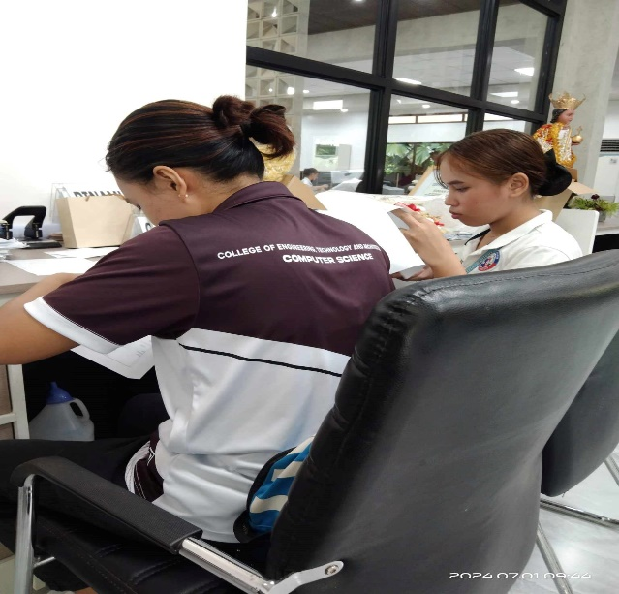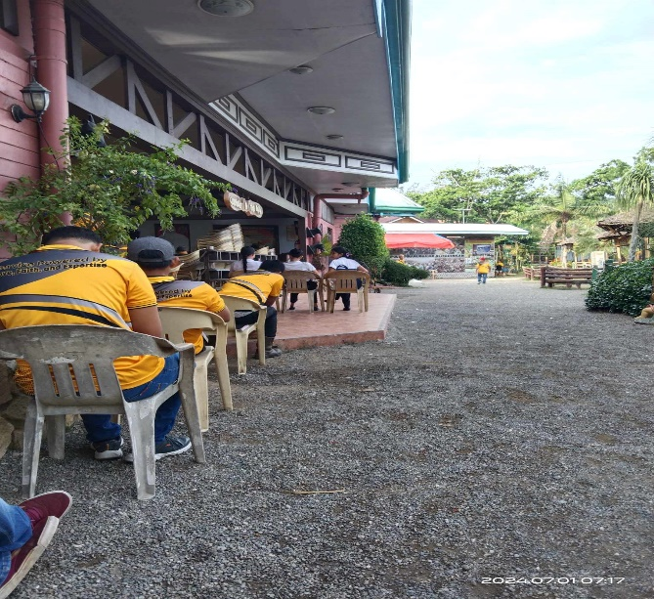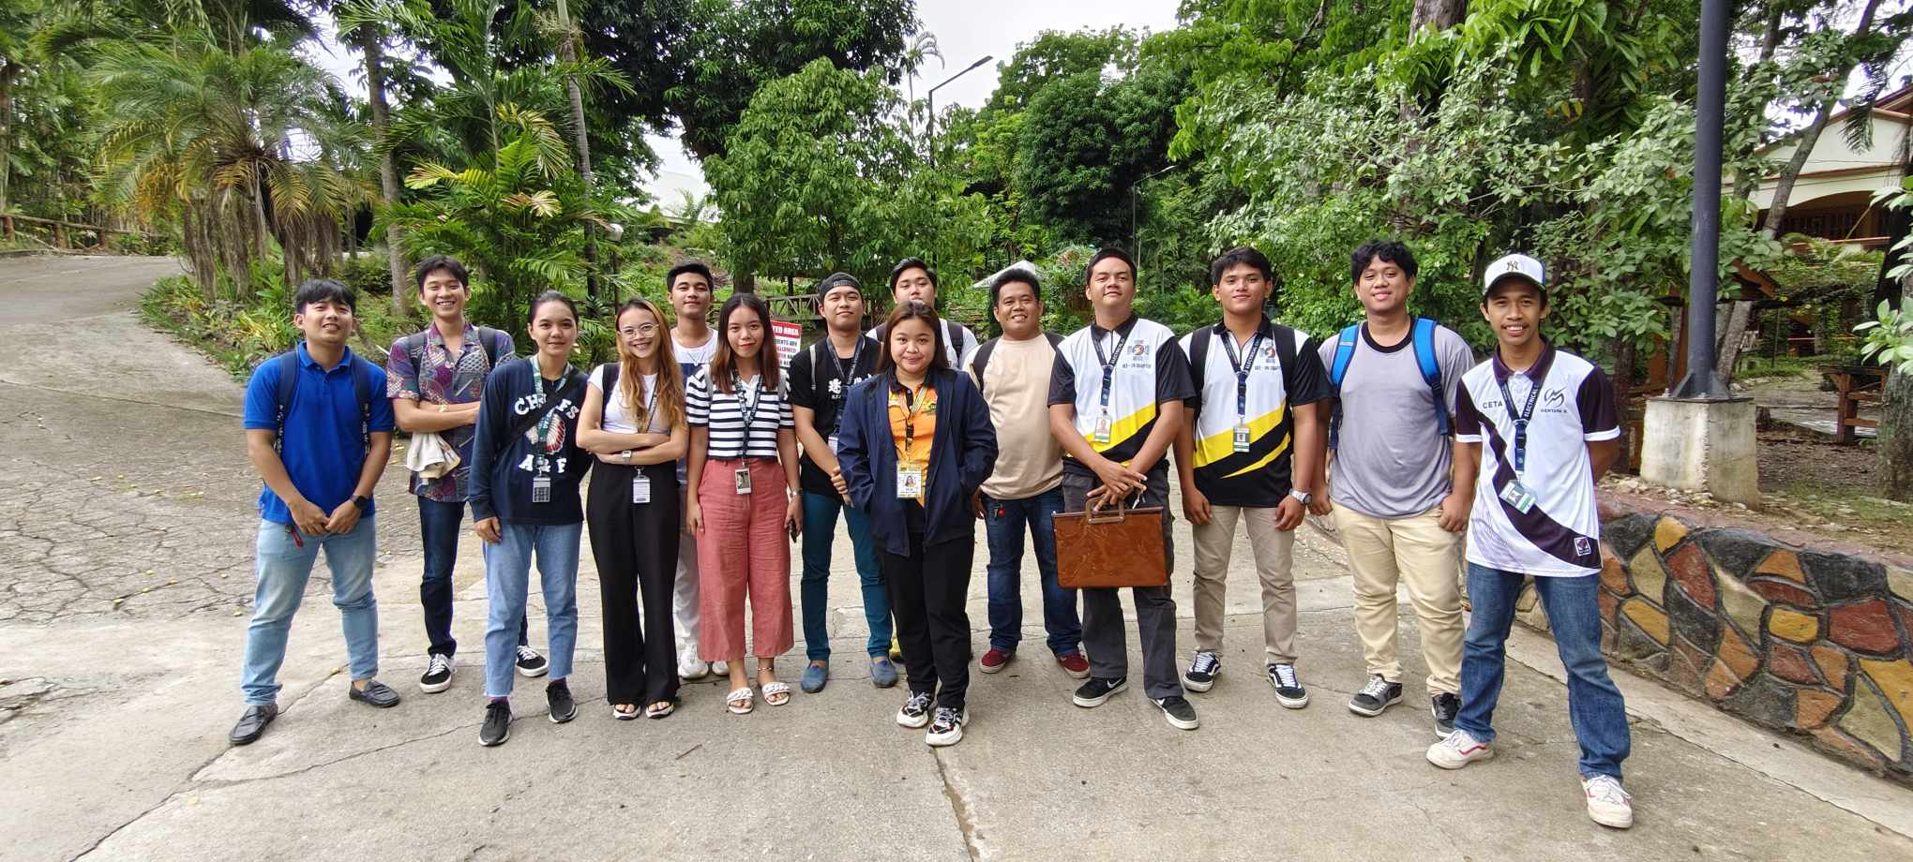**OJT PRESENTATION**